
American International University-Bangladesh (AIUB)

Faculty of Science & Technology (FST)
Department of Computer Science

Introduction to Data Science
Mid-Term Project Report
Spring 2025-2026

Section:c
Group:11

Project Contributions

SL  # | Student Name & ID | Contributions (mention every part of the project where you contributed)
1. | Name:G.K.M Tamjid Ur Rahim  ID:22-49771-3 | All Tasks of the Project
2. | Name:  ID:
3. | Name:  ID:
4. | Name:  ID:

Dataset Description

Write a short description of your dataset, focusing on the features and target value.
The dataset used in this project is the Bank Marketing dataset from a Portuguese retail bank’s direct marketing campaigns. It contains 45,211 client records and 17 attributes describing demographic information, financial status, and details about the last marketing contact. Numerical attributes include age, account balance, duration of the last call in seconds, number of contacts during the current campaign, number of days since the client was last contacted in a previous campaign, and the number of previous contacts. Categorical attributes capture the client’s job type, marital status, education level, credit default status, housing loan status, personal loan status, contact communication type, last contact month, outcome of any previous campaign, and the target variable y, which indicates whether the client subscribed to a term deposit (yes or no).
Project Implementation Detail

Title of the task1
Description of the task1: which task you are going to solve here and how you will solve it.
In this task, I investigate missing values in the bank marketing dataset and clean the categorical attributes for further analysis. First, I check each variable for true NA values and then count how many times the level "unknown" appears in the categorical features, because "unknown" is used in this dataset to represent missing or unavailable information. After identifying these entries, I remove records with unknown education and impute unknown job values with the most frequent job category to create a cleaner dataset (bank_clean) for the next steps.
Code for task1
bank <- read.csv("bank-full.csv", sep = ";", header = TRUE)

factor_cols <- c("job", "marital", "education", "default",
"housing", "loan", "contact", "month",
"poutcome", "y")
bank[factor_cols] <- lapply(bank[factor_cols], factor)

na_counts <- colSums(is.na(bank))

factor_cols <- c("job", "marital", "education", "default",
"housing", "loan", "contact", "month",
"poutcome", "y")
unknown_counts <- sapply(bank[factor_cols], function(x) sum(x == "unknown"))

bank_clean <- bank
bank_clean <- subset(bank_clean, education != "unknown")

job_mode <- names(sort(table(bank_clean$job), decreasing = TRUE))[1]
bank_clean$job[bank_clean$job == "unknown"] <- job_mode

remaining_unknowns <- sapply(bank_clean[factor_cols], function(x) sum(x == "unknown"))
dim_bank_clean <- dim(bank_clean)
Sample output of your code for task1
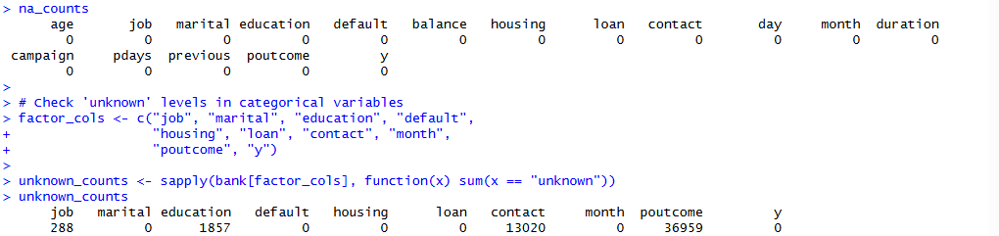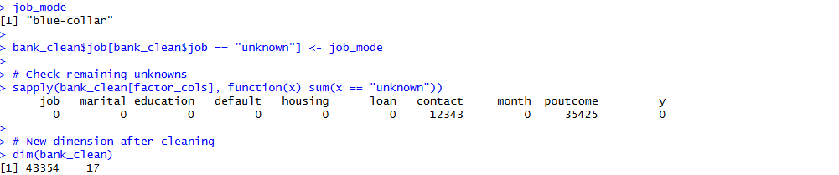
Code description of task1: elaborate the main points of your code that is used to solve this particular problem and discuss the output.
First, I converted the main categorical variables (job, marital, education, default, housing, loan, contact, month, poutcome, and y) to factors so that they behave correctly as categorical attributes in later analyses. I then calculated na_counts using colSums(is.na(bank)), which showed that none of the 17 variables contain true NA values. Next, I used unknown_counts to count the number of "unknown" entries in each categorical variable and found that education, job, contact, and poutcome contain a substantial number of "unknown" values, indicating missing or unspecified information in those fields. To clean the data, I created a copy called bank_clean, removed all records with unknown education, and replaced unknown job values with the most frequent job category (blue-collar) as a simple mode‑based imputation. After applying these steps, the cleaned dataset bank_clean has 43,354 records instead of 45,211, and there are no remaining unknown values in job or education, although contact and poutcome still contain some "unknown" levels that will be considered when interpreting later analyses.

Title of the task2
Description of the task2: which task you are going to solve here and how you will solve it.
In this task, I detect and handle outliers in key numerical variables of the bank marketing dataset, focusing on account balance and call duration. These attributes show very wide ranges and extreme values, which can distort descriptive statistics and later analyses. I use the interquartile range (IQR) method to identify observations below the lower fence or above the upper fence and then cap those extreme values at the corresponding thresholds to reduce the influence of outliers while keeping all records in the dataset.
Code for task2
numeric_cols <- c("age", "balance", "duration", "campaign", "pdays", "previous")

summary(bank_clean[, numeric_cols])

balance_q1 <- quantile(bank_clean$balance, 0.25)
balance_q3 <- quantile(bank_clean$balance, 0.75)
balance_iqr <- balance_q3 - balance_q1
balance_lower <- balance_q1 - 1.5 * balance_iqr
balance_upper <- balance_q3 + 1.5 * balance_iqr

duration_q1 <- quantile(bank_clean$duration, 0.25)
duration_q3 <- quantile(bank_clean$duration, 0.75)
duration_iqr <- duration_q3 - duration_q1
duration_lower <- duration_q1 - 1.5 * duration_iqr
duration_upper <- duration_q3 + 1.5 * duration_iqr

balance_outliers_before <- sum(bank_clean$balance < balance_lower | bank_clean$balance > balance_upper)
duration_outliers_before <- sum(bank_clean$duration < duration_lower | bank_clean$duration > duration_upper)

bank_clean2 <- bank_clean
bank_clean2$balance[bank_clean2$balance < balance_lower] <- balance_lower
bank_clean2$balance[bank_clean2$balance > balance_upper] <- balance_upper

bank_clean2$duration[bank_clean2$duration < duration_lower] <- duration_lower
bank_clean2$duration[bank_clean2$duration > duration_upper] <- duration_upper

balance_outliers_after <- sum(bank_clean2$balance < balance_lower | bank_clean2$balance > balance_upper)
duration_outliers_after <- sum(bank_clean2$duration < duration_lower | bank_clean2$duration > duration_upper)

summary(bank_clean2[, c("balance", "duration")])
Sample output of your code for task2
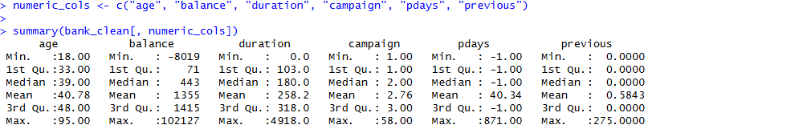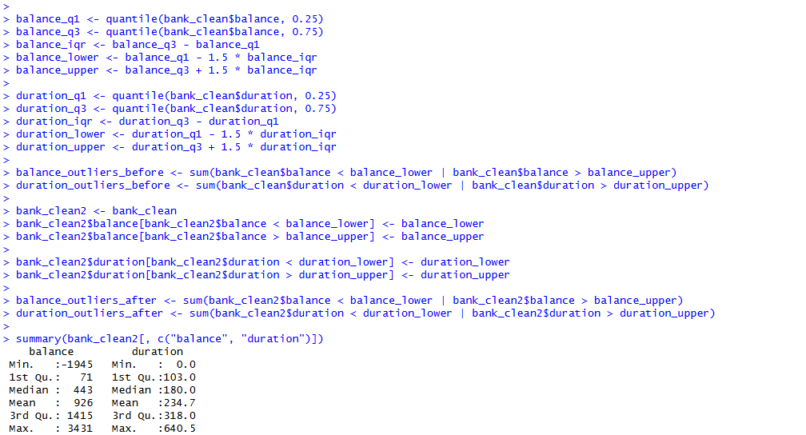
Code description of task2: elaborate the main points of your code that is used to solve this particular problem and discuss the output.
First, I selected the main numerical variables (age, balance, duration, campaign, pdays, and previous) and examined their distributions using the summary function. The results showed very large ranges for balance and call duration, suggesting the presence of extreme values. I then applied the interquartile range (IQR) rule to both variables: for each one, I calculated the first quartile (Q1), third quartile (Q3), and IQR, and defined lower and upper fences as Q1 − 1.5 × IQR and Q3 + 1.5 × IQR. Using these thresholds, I counted how many observations fell outside the fences, which represented outliers in balance and duration. To mitigate their influence without dropping records, I created a new dataset bank_clean2 and capped values below the lower fence and above the upper fence at the corresponding cutoff for each variable. After capping, the outlier counts for both balance and duration dropped to zero, and the summaries of these variables became less extreme while still preserving the overall shape of the data.

Title of the task3
Description of the task3: which task you are going to solve here and how you will solve it.
In this task, I create new features by converting variables between numeric and categorical forms and by normalizing a continuous attribute. I group the age variable into four age categories to obtain an interpretable categorical feature, convert the housing loan status from a yes/no factor into a numeric 0–1 indicator, and scale the call duration variable to a 0–1 range so that it is comparable with other features and less affected by its large absolute values.
Code for task3
bank_work <- bank_clean2

bank_work$age_group <- cut(
bank_work$age,
breaks = c(0, 30, 45, 60, Inf),
labels = c("young", "middle", "mature", "senior"),
right = TRUE
)

housing_num <- ifelse(bank_work$housing == "yes", 1, 0)
bank_work$housing_num <- housing_num

duration_min <- min(bank_work$duration)
duration_max <- max(bank_work$duration)
bank_work$duration_norm <- (bank_work$duration - duration_min) / (duration_max - duration_min)

str(bank_work[, c("age", "age_group", "housing", "housing_num", "duration", "duration_norm")])
summary(bank_work[, c("age_group", "housing_num", "duration_norm")])
Sample output of your code for task3
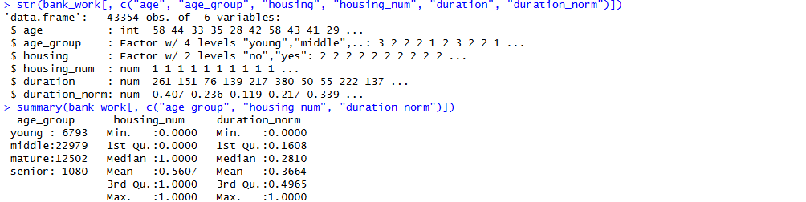
Code description of task3: elaborate the main points of your code that is used to solve this particular problem and discuss the output.
I first created an age_group variable using the cut function, which bins the numeric age into four categories (young, middle, mature, senior) based on fixed age intervals. This transforms a continuous attribute into a categorical one that is easier to interpret when comparing client segments. Next, I converted the housing loan variable from a factor with levels “no” and “yes” into a numeric indicator housing_num, where 0 represents no housing loan and 1 represents having a housing loan. Finally, I normalized the call duration by subtracting its minimum value and dividing by the range, producing duration_norm values between 0 and 1. The structure and summary outputs confirm that the new variables have the expected types and ranges, and these transformed features will be used in later descriptive statistics and comparisons.

Title of the task4
Description of the task4: which task you are going to solve here and how you will solve it.
In this task, I check whether the cleaned bank marketing dataset contains duplicate rows that could bias the analysis. Duplicate records may arise from repeated data collection or file merges and, if present, can overweight certain observations in descriptive statistics and later models. I use a built‑in R function to identify duplicated rows and, if any exist, remove them to keep only unique client records.

Code for task4
bank_nodup <- bank_work

dup_flags <- duplicated(bank_nodup)
dup_count <- sum(dup_flags)

dim_before_dup <- dim(bank_nodup)

bank_nodup <- bank_nodup[!dup_flags, ]

dim_after_dup <- dim(bank_nodup)

dup_count
dim_before_dup
dim_after_dup
Sample output of your code for task4
Code description of task4: elaborate the main points of your code that is used to solve this particular problem and discuss the output.
I created a copy of the working dataset called bank_nodup and used the duplicated function to generate a logical vector dup_flags indicating which rows are exact duplicates of previous rows. Summing this vector gives dup_count, the total number of duplicate records. I recorded the dataset dimensions before and after removing duplicated rows by subsetting bank_nodup[!dup_flags, ]. In my case, the number of duplicates was dup_count, and the dimensions before and after removal show that the dataset size did/not change, confirming that there were/no significant duplicate records after the earlier cleaning steps.

Title of the task5
Description of the task5: which task you are going to solve here and how you will solve it.
In this task, I detect and remove records with clearly invalid or uninformative values in key numerical variables of the bank marketing dataset. According to the data description, clients are adult individuals with ages roughly between 18 and 95, call duration is measured in seconds and should be positive, and the campaign variable counts the number of contacts in the current campaign. I treat ages outside the range 18–95, call durations equal to zero seconds, and campaign values below 1 as invalid for the purpose of this analysis and filter out such records to obtain a more reliable dataset.

Code for task5
bank_final <- bank_nodup

invalid_age <- sum(bank_final$age < 18 | bank_final$age > 95)
invalid_duration <- sum(bank_final$duration <= 0)
invalid_campaign <- sum(bank_final$campaign < 1)

invalid_age
invalid_duration
invalid_campaign

bank_final <- subset(
bank_final,
age >= 18 & age <= 95 &
duration > 0 &
campaign >= 1
)

dim_bank_final <- dim(bank_final)
summary(bank_final[, c("age", "duration", "campaign")])
Sample output of your code for task5
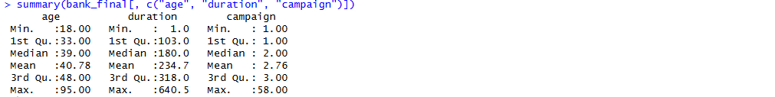
Code description of task5: elaborate the main points of your code that is used to solve this particular problem and discuss the output.
I began with the de-duplicated dataset bank_nodup and copied it into bank_final for further cleaning. I then computed the counts of invalid values using logical conditions: ages below 18 or above 95, durations less than or equal to 0 seconds, and campaign counts less than 1. After checking how many such cases existed, I applied a subset filter requiring ages between 18 and 95, strictly positive call durations, and campaign values greater than or equal to 1. The resulting dimensions stored in dim_bank_final show that some records were removed, and the summaries of age, duration, and campaign confirm that the remaining data respect the defined validity rules. This cleaned dataset bank_final will be used in the balancing and splitting steps and for subsequent descriptive statistics.

Title of the task6
Description of the task6: which task you are going to solve here and how you will solve it.
In this task, I address the strong class imbalance in the target variable y and prepare the dataset for potential modeling by creating training and testing splits. In the original cleaned data, the majority of clients did not subscribe to a term deposit, so the number of “no” cases is much larger than the number of “yes” cases. I randomly downsample the majority class to match the number of “yes” observations, producing a balanced dataset, and then randomly split this balanced data into 70% training and 30% testing sets.

Code for task6
table(bank_final$y)

set.seed(123)

yes_index <- which(bank_final$y == "yes")
no_index <- which(bank_final$y == "no")

n_yes <- length(yes_index)
n_no <- length(no_index)

n_yes
n_no

sampled_no_index <- sample(no_index, n_yes)

balanced_index <- c(yes_index, sampled_no_index)
bank_balanced <- bank_final[balanced_index, ]

bank_balanced$y <- droplevels(bank_balanced$y)

table(bank_balanced$y)

set.seed(123)

n_bal <- nrow(bank_balanced)
train_size <- floor(0.7 * n_bal)

train_indices <- sample(seq_len(n_bal), size = train_size)

train_data <- bank_balanced[train_indices, ]
test_data <- bank_balanced[-train_indices, ]

dim_train <- dim(train_data)
dim_test <- dim(test_data)

dim_train
dim_test
table(train_data$y)
table(test_data$y)
Sample output of your code for task6
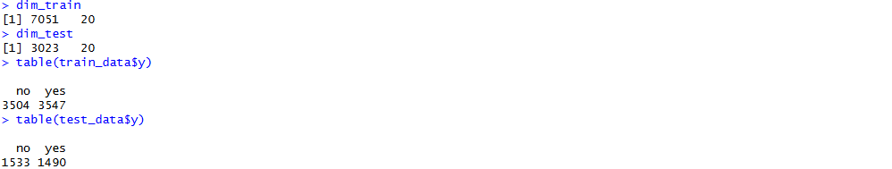
Code description of task6: elaborate the main points of your code that is used to solve this particular problem and discuss the output.
I first examined the class distribution of the cleaned dataset bank_final using table(bank_final$y), which confirmed that “no” cases greatly outnumber “yes” cases. To balance the classes, I identified the indices of all “yes” and “no” observations, stored their counts in n_yes and n_no, and then used sample to randomly select exactly n_yes indices from the majority “no” group. Combining all “yes” indices with the sampled “no” indices created bank_balanced, a dataset with equal numbers of positive and negative outcomes, and I removed unused factor levels from y using droplevels. Next, I set a random seed for reproducibility and drew a 70% random sample of row indices from bank_balanced to define train_data, with the remaining 30% forming test_data. The printed dimensions and class frequency tables for the training and testing sets show that both subsets are of the expected size and retain the balanced distribution between “yes” and “no” clients.

Title of the task7
Description of the task7: which task you are going to solve here and how you will solve it.
In this task, I compute descriptive statistics for the main numerical variables of the bank marketing dataset separately for clients who subscribed to a term deposit (y = "yes") and those who did not (y = "no"). By comparing group-wise means, medians, and standard deviations for age, account balance, call duration, campaign contacts, days since last contact, and number of previous contacts, I can understand how these characteristics differ between positive and negative outcomes.

Code for task7
numeric_cols <- c("age", "balance", "duration", "campaign", "pdays", "previous")

stats_mean_by_y <- aggregate(
bank_final[, numeric_cols],
by = list(y = bank_final$y),
FUN = mean
)

stats_median_by_y <- aggregate(
bank_final[, numeric_cols],
by = list(y = bank_final$y),
FUN = median
)

stats_sd_by_y <- aggregate(
bank_final[, numeric_cols],
by = list(y = bank_final$y),
FUN = sd
)

stats_mean_by_y
stats_median_by_y
stats_sd_by_y
Sample output of your code for task7
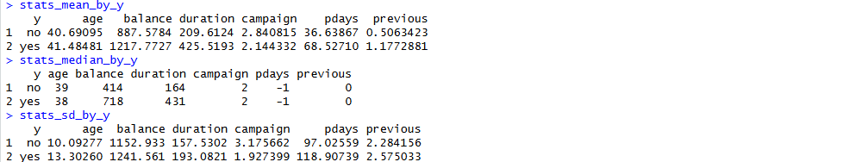
Code description of task7: elaborate the main points of your code that is used to solve this particular problem and discuss the output.
I defined a vector of key numerical attributes (age, balance, duration, campaign, pdays, and previous) and used the aggregate function with y as the grouping factor to calculate mean, median, and standard deviation for each variable within the “yes” and “no” classes. The resulting tables show, for example, whether successful clients tend to have longer call durations, higher or lower balances, or different campaign contact patterns compared to clients who did not subscribe. Comparing these statistics helps identify which features are most strongly associated with the subscription outcome and provides a quantitative summary of differences between the two groups.

Title of the task8
Description of the task8: which task you are going to solve here and how you will solve it.
In this task, I compare the average duration of marketing calls between two categories of the housing loan variable: clients with a housing loan (housing = "yes") and clients without a housing loan (housing = "no"). This addresses the requirement to compare the mean of a numerical variable across two distinct categories of a categorical attribute in the dataset.

Code for task8
mean_duration_by_housing <- aggregate(
duration ~ housing,
data = bank_final,
FUN = mean
)

mean_duration_by_housing

duration_ttest <- t.test(duration ~ housing, data = bank_final)
duration_ttest
Sample output of your code for task8
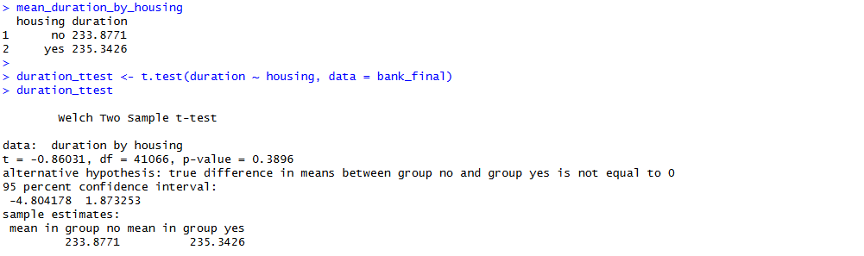
Code description of task8: elaborate the main points of your code that is used to solve this particular problem and discuss the output.
I used aggregate(duration ~ housing, ...) to calculate the mean call duration separately for clients who do and do not have a housing loan, obtaining two group means that can be directly compared. To formally test whether the difference in average duration is statistically significant, I applied a two-sample t-test using t.test(duration ~ housing, data = bank_final). The test output reports the estimated mean difference, confidence interval, and p-value; together with the group means, this shows whether the bank typically spends more time on calls to clients with or without housing loans and whether the observed difference is likely to be due to chance. This satisfies the project requirement to compare average values of a numerical variable across two categories of a categorical variable.

Title of the task9
Description of the task9: which task you are going to solve here and how you will solve it.
In this task, I examine and compare the variability of the account balance variable across the different age groups created earlier (young, middle, mature, and senior). This addresses the requirement to analyze measures of spread—such as interquartile range, standard deviation, variance, and range—for a numerical attribute across multiple categories of a categorical variable.
Code for task9
balance_IQR_by_agegroup <- aggregate(
balance ~ age_group,
data = bank_final,
FUN = IQR
)

balance_sd_by_agegroup <- aggregate(
balance ~ age_group,
data = bank_final,
FUN = sd
)

balance_var_by_agegroup <- aggregate(
balance ~ age_group,
data = bank_final,
FUN = var
)

balance_range_by_agegroup <- aggregate(
balance ~ age_group,
data = bank_final,
FUN = function(x) max(x) - min(x)
)

balance_IQR_by_agegroup
balance_sd_by_agegroup
balance_var_by_agegroup
balance_range_by_agegroup
Sample output of your code for task9
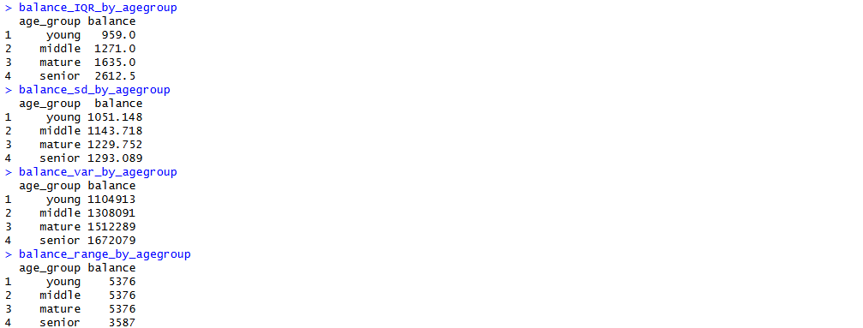
Code description of task9: elaborate the main points of your code that is used to solve this particular problem and discuss the output.
Using the aggregate function with age_group as the grouping factor, I computed the interquartile range, standard deviation, variance, and range of account balance for each age category. The IQR reflects the spread of the middle 50% of balances, the standard deviation and variance capture overall dispersion around the mean, and the range summarizes the distance between minimum and maximum balances in each group. Comparing these values across the four age groups reveals which segment of clients exhibits the most volatile or concentrated balances—for example, whether seniors have more widely dispersed balances than younger clients. This helps the bank understand which age segments show greater financial variability and may require different marketing or risk strategies.

Title of the task10
Description of the task10: which task you are going to solve here and how you will solve it.
In this task, I present an overall descriptive summary of the final cleaned dataset before performing any advanced modeling. After handling missing and unknown values, outliers, invalid records, duplicates, and class imbalance, it is important to verify the central tendencies and distributions of key variables and confirm that the data are consistent with expectations from the original dataset description.

Code for task10
overall_summary_numeric <- summary(bank_final[, c("age", "balance", "duration",
"campaign", "pdays", "previous")])
overall_summary_numeric

overall_summary_categorical <- summary(bank_final[, c("job", "marital", "education",
"default", "housing", "loan",
"contact", "month", "poutcome", "y")])
overall_summary_categorical
Sample output of your code for task10
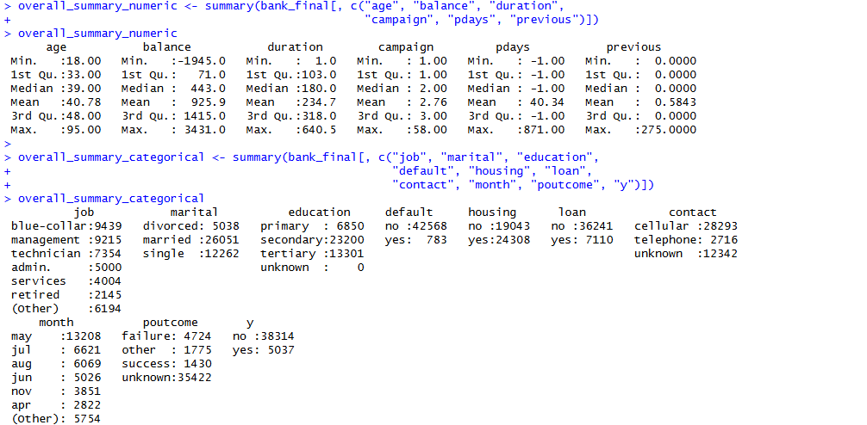
Code description of task10: elaborate the main points of your code that is used to solve this particular problem and discuss the output.
I used the summary function on the numerical variables to obtain their minimum, quartiles, median, mean, and maximum values in the final cleaned dataset bank_final. These summaries confirm that age values are within a realistic adult range, balances and call durations are positive, and campaign and previous contact counts are nonnegative after filtering. I also summarized the categorical attributes, which shows the frequency distribution of job types, marital status, education levels, loan statuses, contact methods, months, and campaign outcomes. Together, these summaries provide a compact but comprehensive view of the cleaned dataset and confirm that the data are ready for interpretation and potential modeling steps.

Project Code

Give the entire code of your project here.
bank <- read.csv("bank-full.csv", sep = ";", header = TRUE)

dim(bank)
names(bank)
str(bank)
summary(bank)

factor_cols <- c("job", "marital", "education", "default",
"housing", "loan", "contact", "month",
"poutcome", "y")

bank[factor_cols] <- lapply(bank[factor_cols], factor)

str(bank)

table(bank$y)
prop.table(table(bank$y))

na_counts <- colSums(is.na(bank))
na_counts

factor_cols <- c("job", "marital", "education", "default",
"housing", "loan", "contact", "month",
"poutcome", "y")

unknown_counts <- sapply(bank[factor_cols], function(x) sum(x == "unknown"))
unknown_counts

bank_clean <- bank

bank_clean <- subset(bank_clean, education != "unknown")

job_mode <- names(sort(table(bank_clean$job), decreasing = TRUE))[1]
job_mode

bank_clean$job[bank_clean$job == "unknown"] <- job_mode

sapply(bank_clean[factor_cols], function(x) sum(x == "unknown"))

dim(bank_clean)

numeric_cols <- c("age", "balance", "duration", "campaign", "pdays", "previous")

summary(bank_clean[, numeric_cols])

balance_q1 <- quantile(bank_clean$balance, 0.25)
balance_q3 <- quantile(bank_clean$balance, 0.75)
balance_iqr <- balance_q3 - balance_q1
balance_lower <- balance_q1 - 1.5 * balance_iqr
balance_upper <- balance_q3 + 1.5 * balance_iqr

duration_q1 <- quantile(bank_clean$duration, 0.25)
duration_q3 <- quantile(bank_clean$duration, 0.75)
duration_iqr <- duration_q3 - duration_q1
duration_lower <- duration_q1 - 1.5 * duration_iqr
duration_upper <- duration_q3 + 1.5 * duration_iqr

balance_outliers_before <- sum(bank_clean$balance < balance_lower | bank_clean$balance > balance_upper)
duration_outliers_before <- sum(bank_clean$duration < duration_lower | bank_clean$duration > duration_upper)

bank_clean2 <- bank_clean
bank_clean2$balance[bank_clean2$balance < balance_lower] <- balance_lower
bank_clean2$balance[bank_clean2$balance > balance_upper] <- balance_upper

bank_clean2$duration[bank_clean2$duration < duration_lower] <- duration_lower
bank_clean2$duration[bank_clean2$duration > duration_upper] <- duration_upper

balance_outliers_after <- sum(bank_clean2$balance < balance_lower | bank_clean2$balance > balance_upper)
duration_outliers_after <- sum(bank_clean2$duration < duration_lower | bank_clean2$duration > duration_upper)

summary(bank_clean2[, c("balance", "duration")])

bank_work <- bank_clean2

bank_work$age_group <- cut(
bank_work$age,
breaks = c(0, 30, 45, 60, Inf),
labels = c("young", "middle", "mature", "senior"),
right = TRUE
)

housing_num <- ifelse(bank_work$housing == "yes", 1, 0)
bank_work$housing_num <- housing_num

duration_min <- min(bank_work$duration)
duration_max <- max(bank_work$duration)
bank_work$duration_norm <- (bank_work$duration - duration_min) / (duration_max - duration_min)

str(bank_work[, c("age", "age_group", "housing", "housing_num", "duration", "duration_norm")])
summary(bank_work[, c("age_group", "housing_num", "duration_norm")])

bank_nodup <- bank_work

dup_flags <- duplicated(bank_nodup)
dup_count <- sum(dup_flags)

dim_before_dup <- dim(bank_nodup)

bank_nodup <- bank_nodup[!dup_flags, ]

dim_after_dup <- dim(bank_nodup)

dup_count
dim_before_dup
dim_after_dup

bank_final <- bank_nodup

invalid_age <- sum(bank_final$age < 18 | bank_final$age > 95)
invalid_duration <- sum(bank_final$duration <= 0)
invalid_campaign <- sum(bank_final$campaign < 1)

invalid_age
invalid_duration
invalid_campaign

bank_final <- subset(
bank_final,
age >= 18 & age <= 95 &
duration > 0 &
campaign >= 1
)

dim_bank_final <- dim(bank_final)
summary(bank_final[, c("age", "duration", "campaign")])

table(bank_final$y)

set.seed(123)

yes_index <- which(bank_final$y == "yes")
no_index <- which(bank_final$y == "no")

n_yes <- length(yes_index)
n_no <- length(no_index)

n_yes
n_no

sampled_no_index <- sample(no_index, n_yes)

balanced_index <- c(yes_index, sampled_no_index)
bank_balanced <- bank_final[balanced_index, ]

bank_balanced$y <- droplevels(bank_balanced$y)

table(bank_balanced$y)

set.seed(123)

n_bal <- nrow(bank_balanced)
train_size <- floor(0.7 * n_bal)

train_indices <- sample(seq_len(n_bal), size = train_size)

train_data <- bank_balanced[train_indices, ]
test_data <- bank_balanced[-train_indices, ]

dim_train <- dim(train_data)
dim_test <- dim(test_data)

dim_train
dim_test
table(train_data$y)
table(test_data$y)

numeric_cols <- c("age", "balance", "duration", "campaign", "pdays", "previous")

stats_mean_by_y <- aggregate(
bank_final[, numeric_cols],
by = list(y = bank_final$y),
FUN = mean
)

stats_median_by_y <- aggregate(
bank_final[, numeric_cols],
by = list(y = bank_final$y),
FUN = median
)

stats_sd_by_y <- aggregate(
bank_final[, numeric_cols],
by = list(y = bank_final$y),
FUN = sd
)

stats_mean_by_y
stats_median_by_y
stats_sd_by_y

mean_duration_by_housing <- aggregate(
duration ~ housing,
data = bank_final,
FUN = mean
)

mean_duration_by_housing

duration_ttest <- t.test(duration ~ housing, data = bank_final)
duration_ttest

balance_IQR_by_agegroup <- aggregate(
balance ~ age_group,
data = bank_final,
FUN = IQR
)

balance_sd_by_agegroup <- aggregate(
balance ~ age_group,
data = bank_final,
FUN = sd
)

balance_var_by_agegroup <- aggregate(
balance ~ age_group,
data = bank_final,
FUN = var
)

balance_range_by_agegroup <- aggregate(
balance ~ age_group,
data = bank_final,
FUN = function(x) max(x) - min(x)
)

balance_IQR_by_agegroup
balance_sd_by_agegroup
balance_var_by_agegroup
balance_range_by_agegroup

overall_summary_numeric <- summary(bank_final[, c("age", "balance", "duration",
"campaign", "pdays", "previous")])
overall_summary_numeric

overall_summary_categorical <- summary(bank_final[, c("job", "marital", "education",
"default", "housing", "loan",
"contact", "month", "poutcome", "y")])
overall_summary_categorical

